* **Implement Virtualization Using Hyper-V:**
* **Hyper-V** is Microsoft's hardware virtualization product.
* It lets you create and run a software version of a computer, called a *virtual machine*.
* Each virtual machine acts like a complete computer, running an operating system and programs.
* When you need computing resources, virtual machines give you more flexibility, help save time and money, and are a more efficient way to use hardware than just running one operating system on physical hardware.
* **Hyper-V** runs each virtual machine in its own isolated space, which means you can run more than one virtual machine on the same hardware at the same time.
* **Hyper-V** features a **Type 1** hypervisor-based architecture.
* The hypervisor virtualizes processors and memory and provides mechanisms for the virtualization stack in the root partition to manage child partitions (virtual machines) and expose services such as I/O devices to the virtual machines.

* [**How to Create and Run Virtual Machines with Hyper-V**](https://www.howtogeek.com/196158/how-to-create-and-run-virtual-machines-with-hyper-v/)**.**
* First, we must uninstall VMware software if already installed on computer because the VMware Workstation installer does not support running on a Hyper-V virtual machine.
* After uninstalling VMware, we can proceed to next step: -
* Tap the Windows key, type “Windows features” to perform a search, and then click the “Turn Windows features on or off” shortcut. Check the Hyper-V checkbox in the list and click OK to install it. Restart your computer when prompted.

* After Restart Search for Hyper-V manager in search box and click on that.

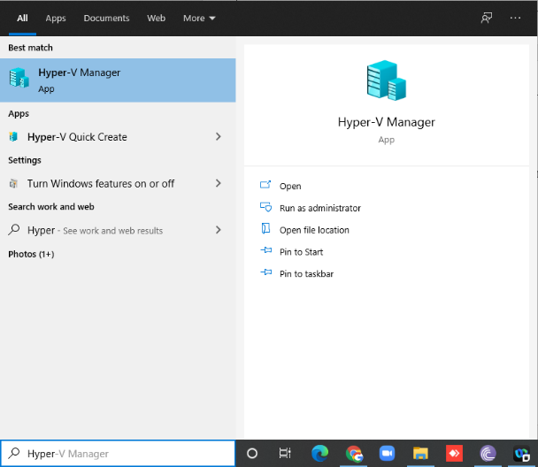

* For creating virtual machine, first we must create virtual switch
* Click on **virtual switch manager** option

* Select External as a connection type and then click on **create virtual switch**

* Give name to your virtual switch then click on **apply** button.

* Now right click on server and select new **virtual machine**.

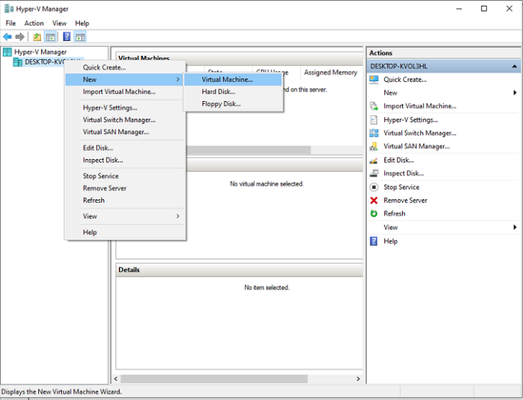

* Click on **Next**
* Provide name to virtual machine then click on **Next** button.

* Specify generation: **Generation 1**

* Tick on use **Dynamic Memory for this virtual machine**.

* Select switch which we created earlier for our virtual machine from drop-down list and then click on **next**.

* Description of virtual machine and location where it will store virtual machine related files and size require for this machine click on **next**

* New virtual machine wizard panel will appear, where we will choose operating system which we want to install on virtual machine.
* Select install an operating system from boot CD/DVD-ROM and then select Image file(.iso) and browse your OS iso file then click on **next** button.

* Summary report will be generated about virtual machine then click on **Finish** button.

* In virtual machine panel your virtual machine will appear which has off state.

* Right click on virtual machine and click on **connect** option.

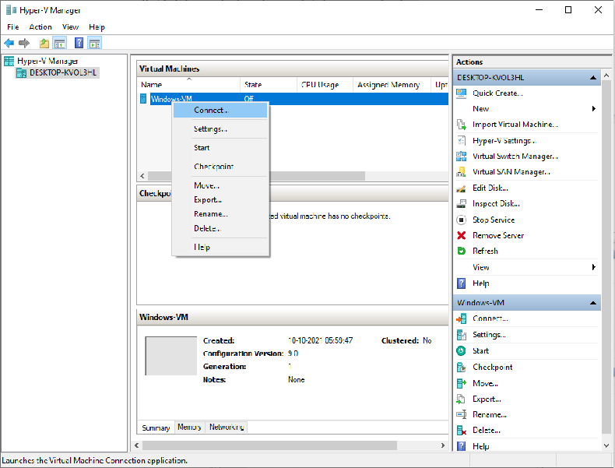

* Now turn on virtual machine.

* Virtual machine will start with below screen.

